HAB2 Minimum Parts Tracker Build

This describes the build of the HAB2 tracker board as a minimum component count high altitude balloon tracker which will be powered by 2 x AAA Energizer Lithium batteries. The components are listed below and what they are for, most can be omitted for this minimum component build.

PCB – This is needed, you can fit an SMA or U.FL socket for the antenna and also form a ¼ wave vertical with radials from guitar wire.

For such a minimum component count tracker powered with 2 x AAA Energizer Lithium batteries there is no need for the regulator on the Arduino Pro Mini as the voltage from the batteries will stay above 2.8V for most of their life, this is enough to run both the LoRa module and the Ublox GPS. These batteries are also rated to operate at -40C. To build the minimum component count tracker you only need to fit the components in red, then put a wire link in place of D1 and a solder bridge on LK1. Follow the instructions ‘Modifying the Pro Mini for Low Power Operation’ at the end of this document to disconnect the LEDs and regulator on the Pro Mini. Fitting LED1 and R5 on the tracker board is not needed but is recommended, it makes testing the board during build easier.

ANT1 – Edge SMA, or just an angles SMA or guitar wire
ANT2 – Ceramic stick GPS antenna or better use guitar wire
BATCON – Where the battery goes, 2 pin 0.1” header or better solder direct wires
C1 – Ceramic decoupler, recommended, 100nF OK, 4.7uF better
C2 – Omitted
C3 – Large value tantalum capacitor, can be omitted
D1A – Surface mount diode, reverse protection for battery, fit if not using 2 x AAAs
D1B – Optional diode to D1A, fit wire link if using 2 x AAAs
D2 – For optional watchdog IC, can be omitted
FS1 – Fit this
IC1 – Optional I2C FRAM
IC2 – Optional Watchdog device
IC3 – The Arduino Pro Mini – this is needed!
IC4 – The LoRa device
IC5 – TC74 Temperature sensor
L1 – Antistatic protection for GPS antenna input, recommended.
LED1 – For indication only, can be omitted
LED2 – For GPS indication only can be omitted
R1 – Needed if reading battery voltage on RAW pin of Pro Mini
R2 - Needed if reading battery voltage on RAW pin of Pro Mini
R3 – For LED2
R5 – For LED1
UBLOX_MAX8Q – Needed

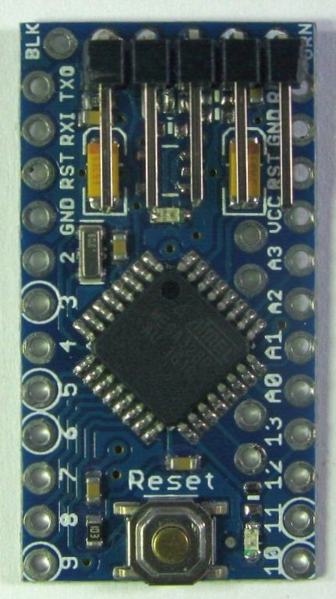

Assembly – for 2 x AAA battery operation.

Note: The UBLOX GPS is very sensitive to static damage on its antenna input, be sure to take proper anti-static precautions when fitting and handling this component, both during assembly and afterwards.

The pictures show the build of a RFM9x based tracker, which can be either 434Mhz or 868Mhz version.

Read the all instructions below before attempting to solder any components, the board has the Pro Mini on one side and the LoRa device on the other, get the assembly sequence wrong and you may not be able to solder these components in place properly.

Make sure your USB to Serial programming adapter used for programming the Pro Mini is set to 3.3V mode, do not use a 5V version, you may well destroy the LoRa device and GPS. Modify the 3.3V Pro Mini as per the ‘Modifying the Pro Mini for Low Power Operation’ at the end of these instructions. This removes the regulator and some resistors.

Fit the 5 pin angled header for the programming connection on the Pro Mini, see below for location.

Check that you can program the Pro Mini by uploading the ‘LED_Blink’ program from the examples folder. When the program is loaded the LED on the Pro Mini should flash (if its fitted) and there will be messages printed to the Arduino IDE serial monitor;

LED_Blink Starting
0 Seconds
1 Seconds
2 Seconds
3 Seconds

Next load the program ‘Register_Test’ from the examples folder. This program will check communications between the Pro Mini and the LoRa module, there is no LoRa module connected to our Pro Mini at this point, so the test will fail and this should be reported to the Serial Monitor as no device responding, like this;

Register_Test Starting
No device responding
Device version 0×00
Frequency at Start 0
Registers at Start
Reg 0 1 2 3 4 5 6 7 8 9 A B C D E F
0×00 00 00 00 00 00 00 00 00 00 00 00 00 00 00 00 00
0x10 00 00 00 00 00 00 00 00 00 00 00 00 00 00 00 00
0x20 00 00 00 00 00 00 00 00 00 00 00 00 00 00 00 00
0x30 00 00 00 00 00 00 00 00 00 00 00 00 00 00 00 00
0x40 00 00 00 00 00 00 00 00 00 00 00 00 00 00 00 00
0x50 00 00 00 00 00 00 00 00 00 00 00 00 00 00 00 00
0x60 00 00 00 00 00 00 00 00 00 00 00 00 00 00 00 00
0x70 00 00 00 00 00 00 00 00 00 00 00 00 00 00 00 00

Also note the LoRa device registers are all 0s

So we have checked that the Pro Mini can be programmed. Next we need to fit the Pro Mini in place and optionally add the LED (recommended). Be careful to fit the headers in the order indicated, if you do not you may not be able to solder the Pro Mini or LoRa module in place properly.

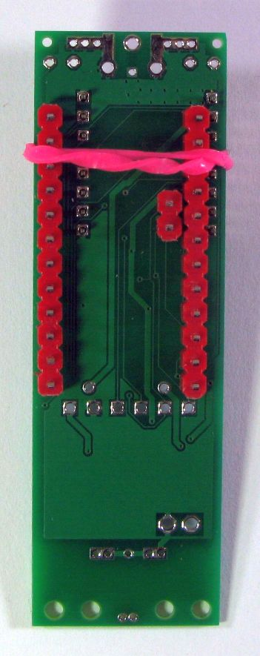

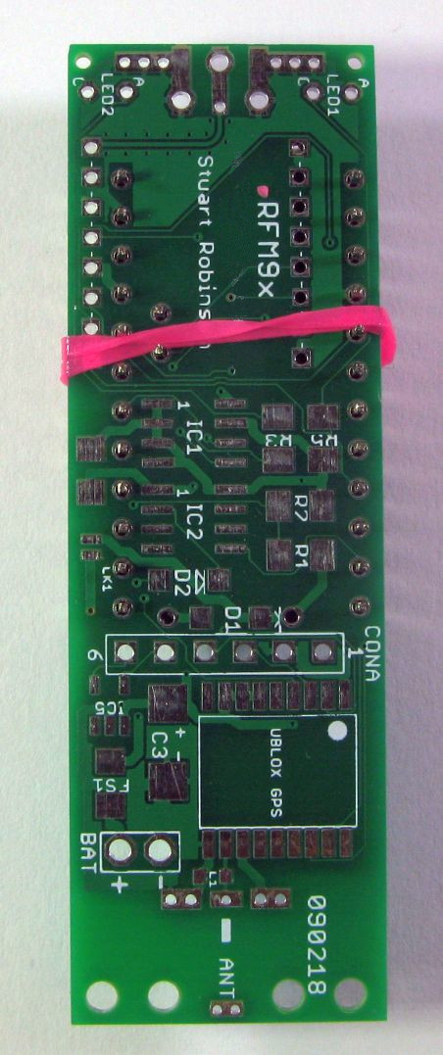

Solder the 0.1” pin headers (shown with the red plastic separator in the picture above) for the Pro Mini in place, 2 x 12pin, 1 x 2 pin, the 2 pin header is to connect up the Pro Minis I2C pins on A4 and A5. Do not solder the Pro Mini itself in place yet.

Solder the 2mm pin headers (2 x 8 pin) for the RFM9x LoRa device or the 0.05” pin headers (1 x 13 pin, 1 x 2 pin) in place for the DRF1278F. Do not solder the LoRa device in place yet.
.
This is a minimum component count tracker, we don’t need the reverse protection diode D1 so fit a shorting link in its place now. This can be done later when the Pro Mini is fitted but it is easier to fit now. Add the wire link where normally D1B fits.

Solder LED1 and R5 in place then Solder the Pro Mini in place. Plug the programming lead back in and the previously loaded ‘LoRa_Module_Test’ will start. The LED should flash slowly twice, then there will be a rapid series of LED flashes, this is the program warning you it cannot find a LoRa module. There will be messages indicating the failure on the serial monitor.

Fit C1 (100nF). C3 can be fitted if you feel the need, but the tracker should work without it. I sometimes fit a 47uF tantalum or ceramic capacitor as a ‘just in case’

Connect a length of wire appropriate for the frequency, 17.5cm for 434Mhz and 8.6cm for 868Mhz to the centre pin of the antenna connector. This will act as a temporary antenna, it will be replaced later with a ¼ wave with radials antenna. Do not operate the LoRa device with no antenna connected. Solder the LoRa module in place, note the correct orientation from the picture of the completed tracker below.

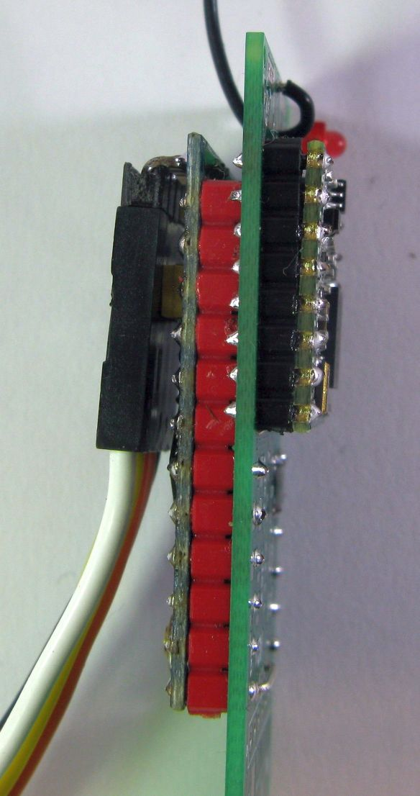

Note the spaces between the boards formed by the plastic separators on the pin headers.
When you reconnect the programmer the program should now not have the rapid LED flashes, and the serial monitor output should show the register contents, see print out;

Register_Test Starting
LoRa Device found
Device version 0x12
Frequency at Start 434199936
Registers at Start
Reg 0 1 2 3 4 5 6 7 8 9 A B C D E F
0x00 00 08 1A 0B 00 52 6C 8C CC F0 09 2B 03 00 02 0A
0x10 FF 00 15 0B 28 0C 12 47 32 3E 00 00 00 00 00 FF
0x20 00 0C 00 00 05 00 03 93 55 55 55 55 55 55 55 55
0x30 90 00 40 00 00 0F 00 00 00 F5 20 82 F4 02 00 40
0x40 00 00 12 24 2D 00 03 00 04 23 00 09 05 84 32 2B
0x50 14 00 00 11 00 00 00 0F E0 00 0C 00 07 00 5C 78
0x60 00 19 0C 4B CC 0E 81 20 04 47 AF 3F F6 3F 8A 0B
0x70 D0 01 10 00 00 00 00 00 00 00 00 00 00 00 00 00
TX Time 218mS

Note that it is normal for an 868Mhz module to have a set frequency of circa 434Mhz on power up or reset. The above printout is for a working LoRa module.

The Ublox 8 GPS antenna input is sensitive to static damage so remember to take anti static precautions whilst soldering the GPS in position and any subsequent handling of the board. As an added precaution you can fit L1 which acts to connect DC wise the antenna input to ground. So solder the GPS in place, some ‘no clean’ flux put on the solder pads on the GPS pads on the PCB will make the soldering easier. Fit the ceramic chip antenna or for a better performing antenna fit a 4.76cm length of guitar wire, I have used Ernie Ball Custom Gauge 9 to 13.

With the GPS and antenna soldered in place load the test program; ‘GPS_Echo’. The output with the GPS just powered on and indoors should look something like this;

GPS_Echo Starting
$GPRMC,,V,,,,,,,,,,N*53
$GPGGA,,,,,,0,00,99.99,,,,,,*48
$GPRMC,,V,,,,,,,,,,N*53
$GPGGA,,,,,,0,00,99.99,,,,,,*48
$GPRMC,,V,,,,,,,,,,N*53
$GPGGA,,,,,,0,00,99.99,,,,,,*48
Put the tracker outside (as you will be unlikely to get a fix indoors) still connected to the program lead either with a long USB cable or uses a nearby PC laptop so that you can monitor the GPS output.

Place the tracker in a location where it has a reasonably clear view of the sky and horizon. You should see the terminal output progress through programming the GPS, and eventually confirm that navigation model 6 is set. After a few minutes the GPS output should change and you will see the latitude and longitude fields filled in. This indicates your GPS has now has a fix, so we can be sure the GPS is working. I would caution against omitting this testing step, knowing the GPS is actually working makes it much easier to troubleshoot potential issues with the completed tracker.

Note that the antennas used for the Ublox GPS are not that effective compared to the large ceramic patch antennas on some GPS’s. This can result in extended initial fix times, particularly if the tracker does not have an unobstructed view of the horizon. Once in flight however the GPS will be above ground clutter and maintaining a good GPS fix is not a problem.

Fit R1 and R2. When your ready to put the tracker in the air you would connect the battery to the two ‘BAT’ pins by the GPS. You can fit a 2 way 0.1” angled pin header here temporarily as the holes are oversized to allow for the pin header to be easily removed and battery leads to be soldered in direct which is more reliable than a plug in connector. If you want to read the batter voltage, you will need to add a wire link between the RAW and VCC pins on the Pro Mini. Whan assembled and the 2 x AAA batteries are connected check the reported versus the actual voltage and adjust the ADMultiplier define in the Settings.h file to have the voltage accurately reported. Fit IC5 if you want a temperature sensor.

A pair of AA Alkalines in a switch box is a handy and low cost way of testing the completed tracker board, although note that whilst AA alkalines are 1.5V when new they do fall to around 1.2V when half discharged. A good rechargeable battery to use for extended testing is the NiZn re-chargeable batteries which have a voltage of around 1.5V each. Do not power this minimum parts build tracker from more than two alkalines or rechargeable batteries, the LoRa device has a voltage maximum of 3.6V only. Be careful not to reverse the connection to the battery, the reverse polarity protection diode has not been fitted.

Program the Pro Mini with the provided ‘Balloon_Tracker_Transmitter_HAB2’ sketch and observe the initial Serial Monitor output, if the GPS programs correctly and navigation model 6 has been set you should hear a tone on a UHF hand-held or SDR in FM mode connected to a PC on the selected tracker frequency. The selected frequency needs to be appropriate for the module in use and is configured in the ‘Settings.h’ file that accompanies the ‘Balloon_Tracker_Transmitter_HAB2’ sketch;

//Tracker mode
const uint32_t TrackerFrequency = 434000000; //frequency of transmissions

Connect the battery to the tracker and place it outside. Monitor with a matching receiver, see the ‘68_Balloon_Tracker_Receiver’ program that is part of the SX12XX-LoRa Library.

Within a couple of minutes the GPS should get a fix and you should start receiving packets.

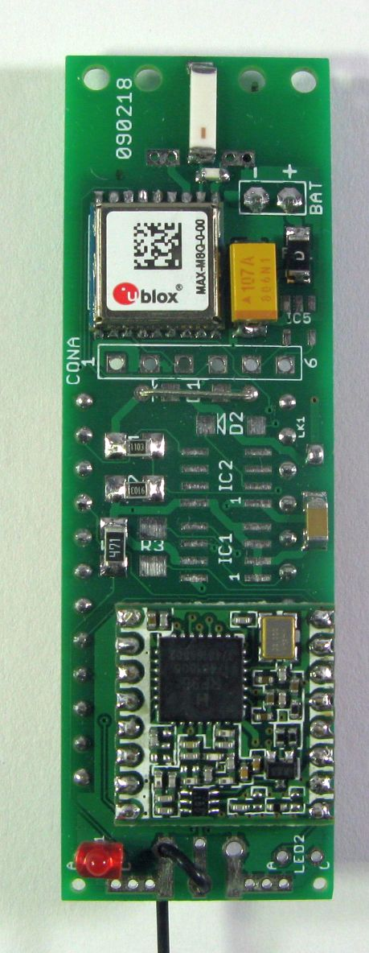
Completed Tracker

Modifying the Pro Mini for Low Power Operation

This tracker is being built for a Pico balloon and as we are going to power it direct from 2 x AAA Lithium batteries (3V), we will need to remove the regulator from the Pro Mini. The two LEDs on the Pro Mini will be also be removed as they just waste power. The easiest way to remove the regulator and not damage the board is to use a very sharp scalpel to cut through the regulator leads at the point they join the regulator body.
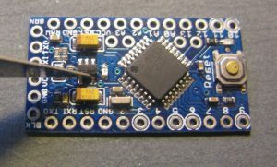

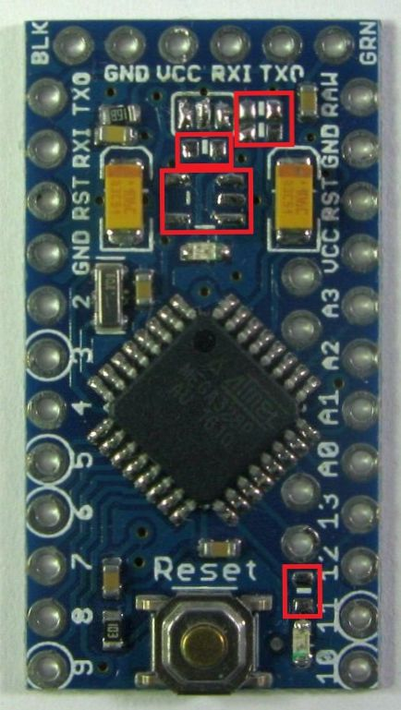
Removing the LEDs can be tricky, so its easier to remove the series resistors for the LEDs instead. This version of Pro Mini also has a resistor feedback network for the regulator across VCC, these consume power so should be removed. Just push the resistors aside with a soldering iron. The picture shows the Pro Mini with unwanted parts removed, locations of the removed components are marked in red.

We need to reprogram the brown out level for the processor, as default the extended fuse is set to 0x05 on the above Pro Minis giving a brown out level detect of 2.7V. This is OK if your using the 3.3V regulator with an external supply, but it too close for a processor running at 2.8V to 3V. I used AVRDUDESS with a USBTiny programmer to reset the fuse to 0x06, giving a 1.8V brownout level. There are plenty of tutorials on the Internet on how to re-program the boot loaders on Arduinos and you can in this re-programming set the extended fuse to 0x06.

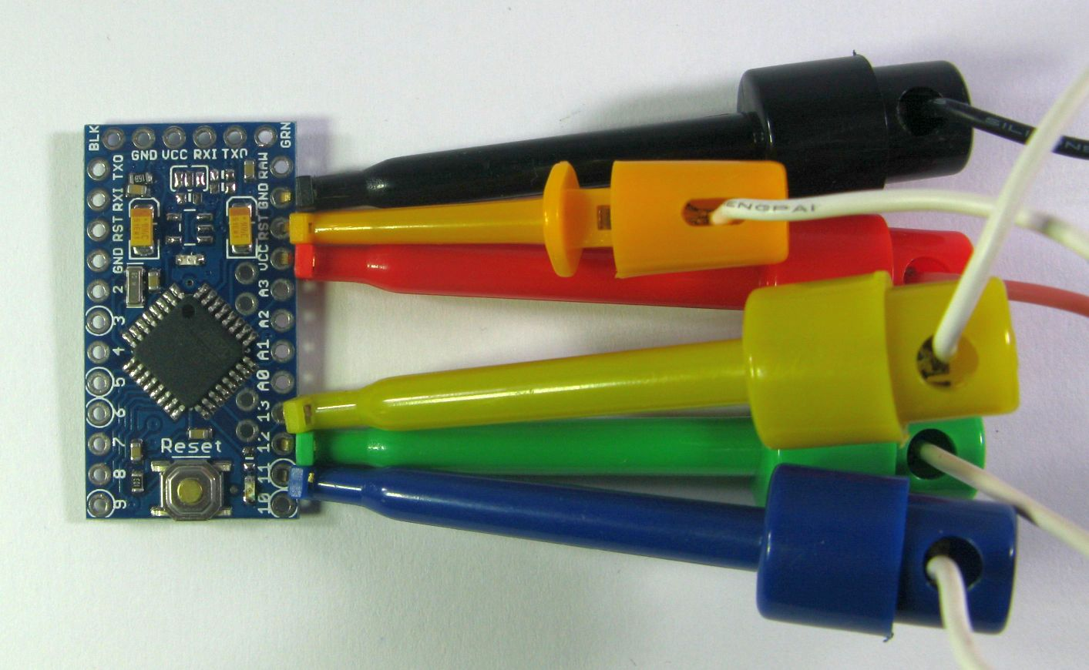

Stuart Robinson
November 2020

